TOUCH SCREEN - COPY OR REPLACE Machine

For example, this job is estimated with hand stripping machined called STRIP. However, there are many plant employees that perform hand stripping. In touch screen, each operator must log in to a machine.  
If each employee logs into the STRIP machine then any job data collection will post their time to that job. For example, we have four men that log into the STRIP Machine at 7AM and Logs out at 3PM. Each man works on four separate jobs. This will post hours for all four men to all four jobs which results in bad job costs.

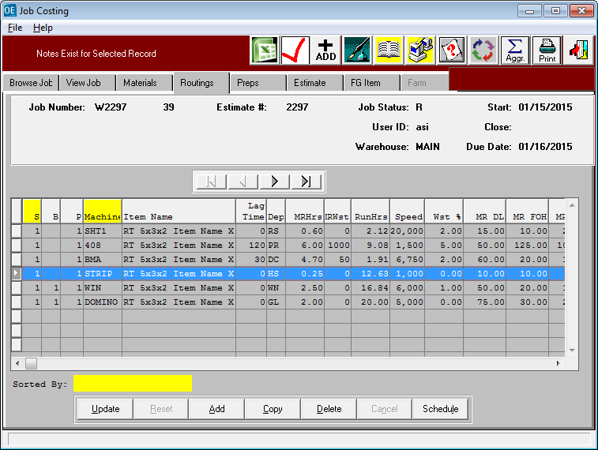

TOUCH SCREEN - COPY OR REPLACE Machine

The solution is to create a unique machine code for each person. For example, HS1, HS2, HS3 and HS4 representing Hand Stripping for Employee one to four. Then each person logs into his own machine code and logs in an out of each machine and enters his own job data collection. When posting job data collection, the employee should COPY his machine otherwise, if two hand strippers are on the SAME JOB, the REPLACE option would remove the first mans machine from the job file.

First Step is to Create Unique Machine Operations in the machine File.

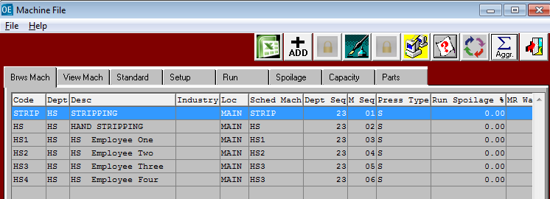

TOUCH SCREEN - COPY OR REPLACE Machine

Next Step is for each employee to login to his specific machine code. Please note, you can create a machine code as the employee ID to simplify data entry. They select their machine code / Employee ID.

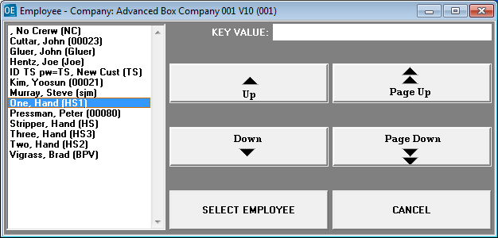

All the machines and operations that employees have logged into will appear on the machine status button so management knows that the machine is ready to run jobs.

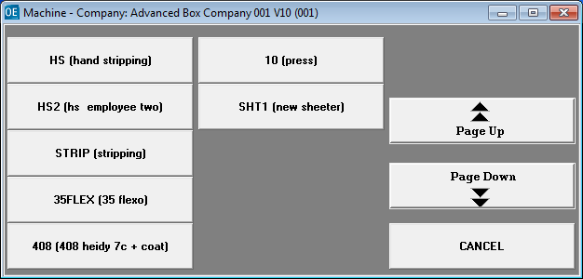

TOUCH SCREEN - COPY OR REPLACE Machine

Next enter JOB DATA COLLECTION and select the Hand Stripping.

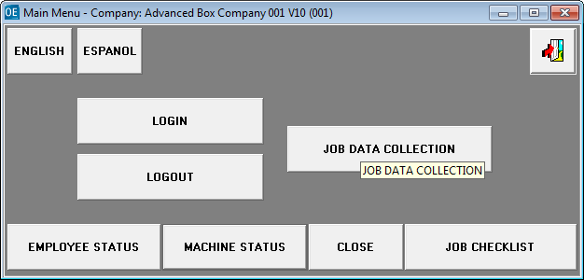

TOUCH SCREEN - COPY OR REPLACE Machine

The job was estimated with the machine code STRIP. The job was estimated with the machine code STRIP. When employee must log onto the machine operation created for him specifically then add labor hours for each job that he works on each day. All the operation codes Strip, HS, HS1, HS2, HS3 and HS4 are in the same department code HS. So, the program prompts to COPY or REPLACE this his machine operation code to the Job file. The Safe option is to always press COPY. However, if there is only 1 person on this job, then REPLACE to then show only one HS department machine code in the job file, job card and job reports.

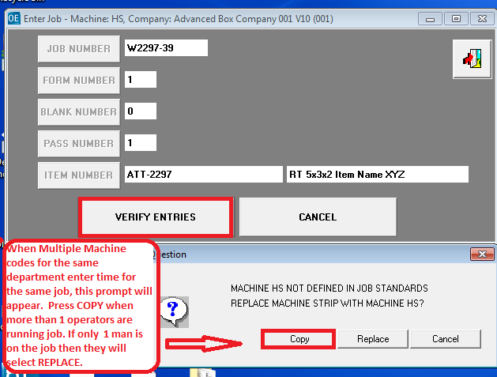

TOUCH SCREEN - COPY OR REPLACE Machine

Each operator enters his own machine setup and run times.

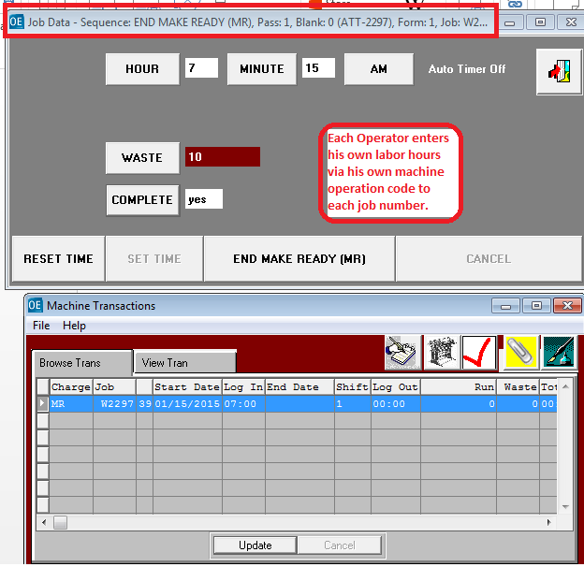

TOUCH SCREEN - COPY OR REPLACE Machine

Each operator enters his own machine setup and run times to his own machine operation code by selecting the COPY button. By having their own operator code, they can move from job to job or work together on the same job. The job cost system will only post hours and cost by the machine operation code.

